Design Your First Home Page

Christine Hodges

Rasmussen College

Author Note

This paper is being submitted on April 7th, 2018 for Professor Darice Corey’s CIS3801 Fundamentals of Mobile Web Application Development Course.

Create your first home page based on the local business you selected in module 1: The home page must include:

* A navigation bar with at least 4 menu options, including a home button or link.
* A logo.
* At least 3 images and text.

Your submission should include the following:

* A Microsoft Word document containing your name, the module and assignment name, description of your site, and your site URL, such as:   
  Presto is a website with information about an app that I am creating in my UWP III course, the website is designed to give more information about all the plans and features that are available

<http://chodgeswebappdev.centralus.cloudapp.azure.com/Module_02/mod2_courseproject_edit.html>

* The URL to your GitHub repository, such as:

<https://github.com/fitactivemomgineer/Presto>

* Screenshots displaying your home page using at least 2 different screen sizes, such as desktop and mobile displays.
* Desktop display
* 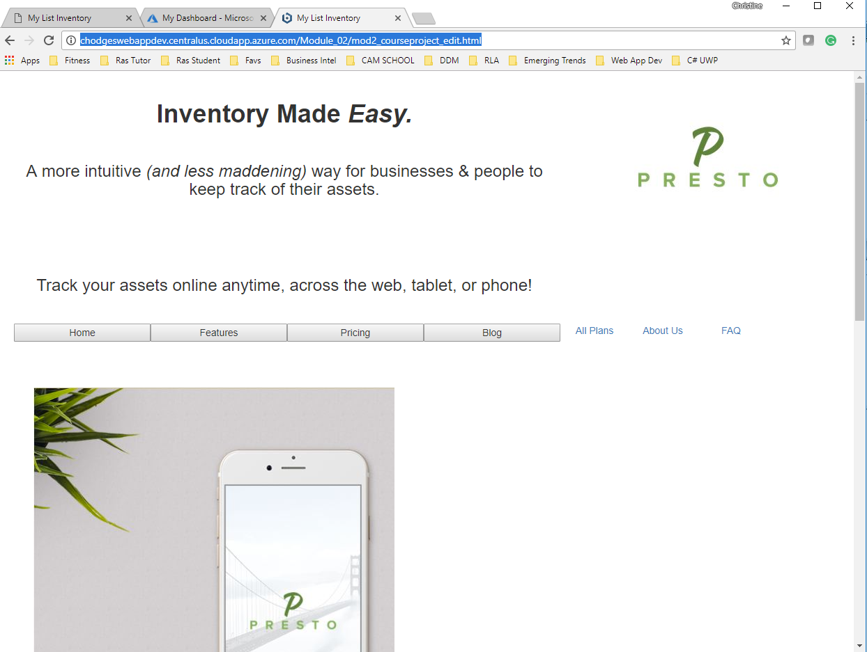

View with an iphone X

